Table 1. Output from modeling capture rate using a negative binomial model with autoregressive correlation structure allowing the habitats to have different rates of decline. Output on the original (log) scale shows there was no significant difference in rates of decline in capture rates among the habitats.

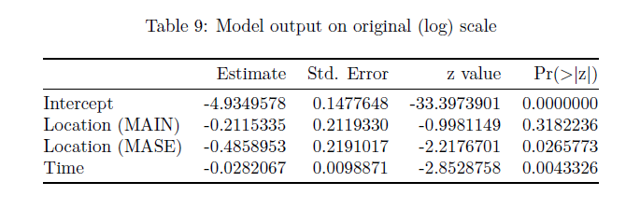

Boris’ comment

Emily wasn’t including same info in table as implied in methods. Boris comment: “test if there is a habitat effect base of AIC we should compare the negative binomial with autocorrelation model with Habitat as a factor with a model without habitat (null model). One more thing. The p values showed in table 1 seem to be significant [MASE looks significant vs baseline], meaning that capture rates among habitats are different. Looking at that same table 1, according to the p value there is a significant time effect that should be mentioned. “

Table 2. Species- level point estimates of capture rates, as well as body size, diet, and habitat variables, of 38 species of birds captured in native montane shrubland (SHRUB), mixed non-native forest (MIXED), and mature secondary subtropical moist broadleaf forest (NATIVE) in the southern Ecuadorian Andes.

|  |  |  |  |  |  |  |  |
| --- | --- | --- | --- | --- | --- | --- | --- |
|  | Point Estimate | | | Body |  | Primary | Habitat |
| Species | SHRUB | MIXED | NATIVE | Sizea | Dietb | Habitatc | Breadthd |
| *Aglaeactis cupripennis* (Shining Sunbeam) | 0.497829969 |  |  | 1 | N | N | 3 |
| *Amblycercus holosericeus* (Yellow-bellied Cacique) |  | 0.633512235 |  | 4 | I | F | 3 |
| *Anisognathus igniventris* (Scarlet-bellied Mountain Tanager) | 0.548722847 | 0.457325754 | 0.620243858 | 4 | O | F | 3 |
| *Anairetes parulus* (Tufted Tit-tyrant) | 0.528072653 |  |  | 1 | I | N | 4 |
| *Atlapetes latinuchus* (Rufous-naped Brush Finch) | 0.510248686 | 0.512987529 | 0.468906561 | 4 | O | E | 3 |
| *Basileuterus coronatus* (Russet-crowned Warbler) |  | 0.693263128 | 0.506283492 | 2 | I | F | 2 |
| *Basileuterus nigrocristatus* (Black-crested Warbler) | 0.668020409 | 0.70334714 | 0.465097043 | 2 | I | E | 4 |
| *Buarremon torquatus* (Stripe-headed Brush Finch) |  | 0.718130493 | 0.469738739 | 4 | O | F | 2 |
| *Catamenia inornata* (Plain-colored Seedeater) | 0.776340228 |  |  | 2 | G | N | 5 |
| *Cistothorus platensis* (Grass Wren) | 0.474145837 |  |  | 2 | I | P | 5 |
| *Conirostrum cinereum* (Cinereous Conebill) | 0.47416254 |  |  | 2 | I | N | 4 |
| *Coeligena iris* (Rainbow Starfrontlet) | 0.648763144 | 0.594243435 | 0.724551053 | 1 | N | F | 4 |
| *Cranioleuca antisiensis* (Line-cheeked Spinetail) |  | 0.523347603 |  | 3 | I | F | 1 |
| *Diglossopis cyanea* (Masked Flowerpiercer) | 0.760899978 | 0.578215157 | 0.564099346 | 2 | O | F | 2 |
| *Diglossa humeralis* (Black Flowerpiercer) | 0.664336181 | 0.478519549 | 0.711277651 | 2 | O | N | 4 |
| *Dubusia taeniata* (Buff-breasted Mountain Tanager) | 0.54107846 |  |  | 4 | O | D | 2 |
| *Eriocnemis luciani* (Sapphire-vented Puffleg) | 0.904864565 | 0.407783175 | 0.445315529 | 1 | N | F | 2 |
| *Eriocnemis vestitus* (Glowing Puffleg) | 0.536009573 |  |  | 1 | N | D | 1 |
| *Grallaria rufula* (Rufous Antpitta) | 0.60574808 | 0.671575448 | 0.378582751 | 4 | I | F | 2 |
| *Hellmayrea gularis* (White-browed Spinetail) | 0.676093741 | 0.787540856 | 0.501162314 | 2 | I | F | 2 |
| *Hemispingus superciliaris* (Superciliated Hemispingus) |  | 0.566647239 | 0.506311329 | 3 | I | F | 3 |
| *Heliangelus viola* (Purple-throated Sunangel) | 0.651061377 | 0.62878436 | 0.587560596 | 1 | N | F | 2 |
| *Lafresnaya lafresnayi* (Mountain Velvetbreast) | 0.364703345 | 0.512879495 | 0.726279907 | 1 | N | F | 2 |
| *Lesbia victoriae* (Black-tailed Trainbearer) | 0.344330801 |  |  | 1 | N | N | 3 |
| *Margarornis squamiger* (Pearled Treerunner) | 0.81255258 |  | 0.614328758 | 3 | I | F | 2 |
| *Metallura baroni* (Violet-throated Metaltail) | 0.791601616 |  |  | 1 | N | D | 3 |
| *Metallura tyrianthina* (Tyrian Metaltail) | 0.715553662 | 0.618632054 | 0.911591133 | 1 | N | D | 3 |
| *Myioborus melanocephalus* (Spectacled Whitestart) | 0.573735737 | 0.56134313 | 0.67066956 | 2 | I | F | 2 |
| *Ochthoeca cinnamomeiventris* (Slaty-backed Chat-Tyrant) |  | 0.53149148 |  | 2 | I | F | 2 |
| *Ochthoeca frontalis* (Crowned Chat-tyrant) | 0.749386063 | 0.58550176 | 0.53720738 | 2 | I | F | 2 |
| *Pterophanes cyanopterus* (Great Sapphirewing) | 0.599286997 |  |  | 2 | N | D | 2 |
| *Scytalopus latrans* (Blackish Tapaculo) | 0.68572901 | 0.675811767 | 0.647341458 | 3 | I | F | 1 |
| *Synallaxis azarae* (Azara's Spinetail) | 0.703973595 | 0.489273969 | 0.425430632 | 3 | I | E | 2 |
| *Tangara vassorii* (Blue-and-black Tanager) | 0.584545541 | 0.511828379 | 0.55919906 | 3 | O | F | 3 |
| *Thripadectes flammulatu*s (Flammulated Treehunter) |  |  | 0.558653253 | 4 | I | F | 2 |
| *Thlypopsis ornata* (Rufous-chested Tanager) | 0.485483373 | 0.586161025 |  | 2 | I | N | 3 |
| *Troglodytes solstitialis* (Mountain Wren) | 0.489617303 | 0.763461232 | 0.489641833 | 2 | I | F | 2 |
| *Zonotrichia capensis* (Rufous-collared Sparrow) | 0.557469638 |  |  | 3 | G | N | 7 |

a 1, 3–9 g; 2, 10–15 g; 3, 16–21 g; 4, >22 g.

b C, carnivore; F, frugivore; G, granivore; I, insectivore; N, nectarivore; O, omnivore (after Ridgely and Greenfield 2001 and pers. obs.).

c D, elfin forest; E, forest edge; F, montane evergreen forest; N, montane shrub and secondary forest; P, páramo grasslands (from Stotz et al. 1996).

d The degree of specialization of the species as represented by the number of habitats occupied (from Stotz et al. 1996).

Figure 1. The estimated time effect for each species in each habitat, as well as the population-level time effect (i.e. the fitted slope). The points and bands correspond to species-level estimates and 95% confidence intervals, respectively. Black points and bands denote species with statistically non-significant trends and red points and bands denote species with statistically significant trends. The light blue shaded region shows the 95% confidence interval for the population-level time effect (0.954, 0.991).

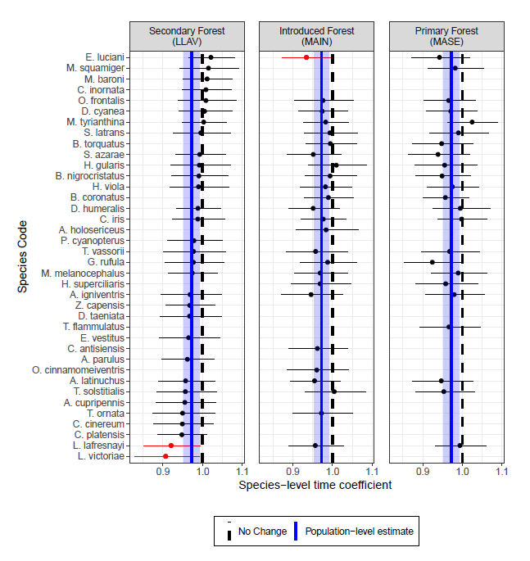

Figure 2a, b, c. Plots of observed and predicted capture rates for three species with significantly declining trends in capture rates: A) Mountain Velvetbreast (*Lafresnaya lafresnayi*), B) Sapphire-vented Puffleg (*Eriocnemis luciani*), and C) Black-tailed Trainbearer (*Lesbia victoriae*). Black points represent observed capture rates standardized to number of captures/1000 mist net hours. The red line (with shaded 95% confidence interval) accounts for session-to-session variability. The blue line is a smoothed predicted trend based on model ouptut.

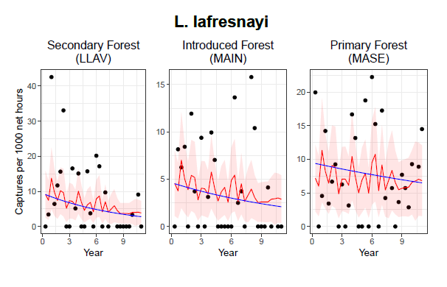

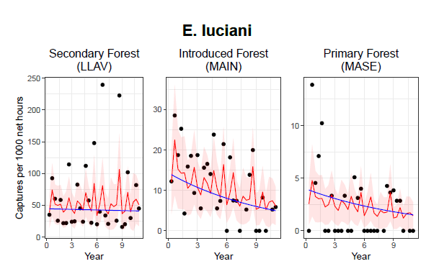

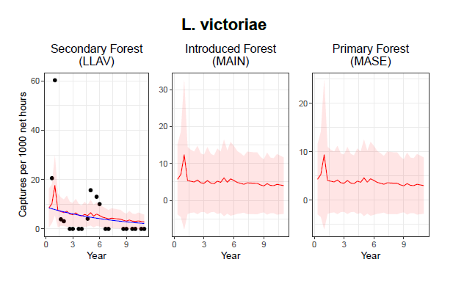

Figure 3. capture rates are changing differently for different ecological groups of bird species including: A) primary diet; B) body size; C) primary habitat occupied; and D) habitat breadth. In all cases, all groups were found to share the decrease in capture rates of 2.8% (95% CI: 0.9-4.7%) per year.

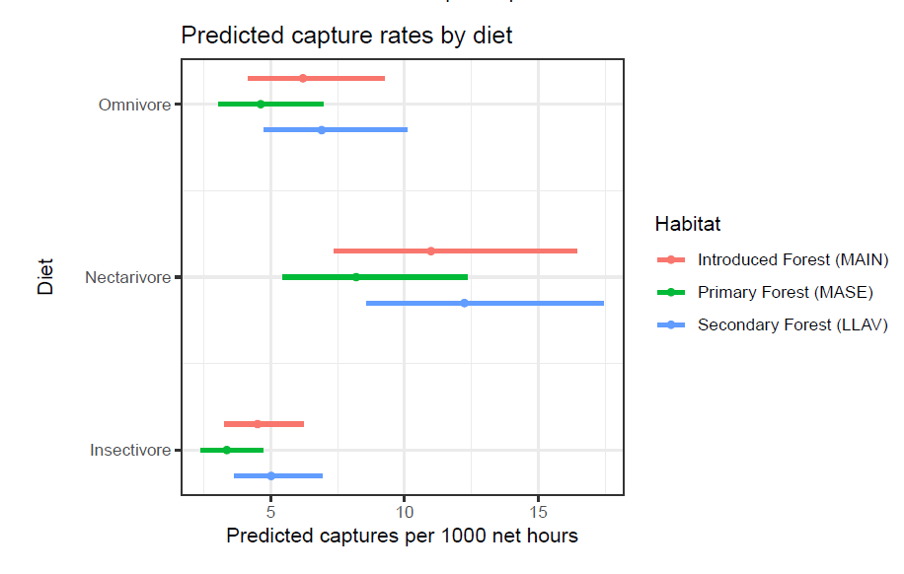

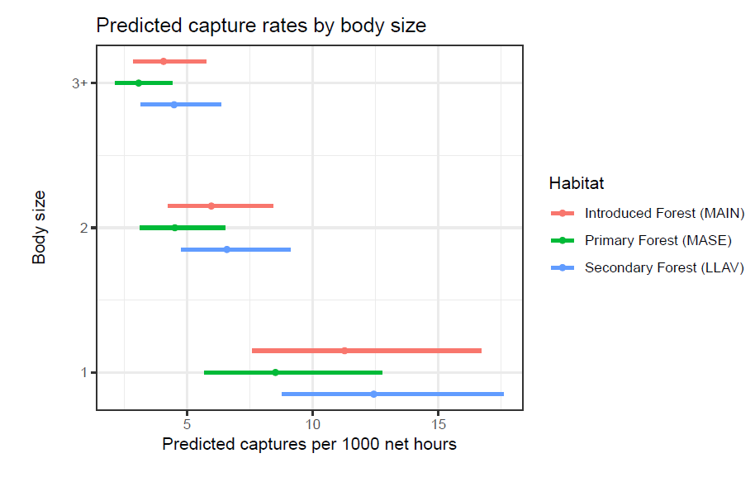

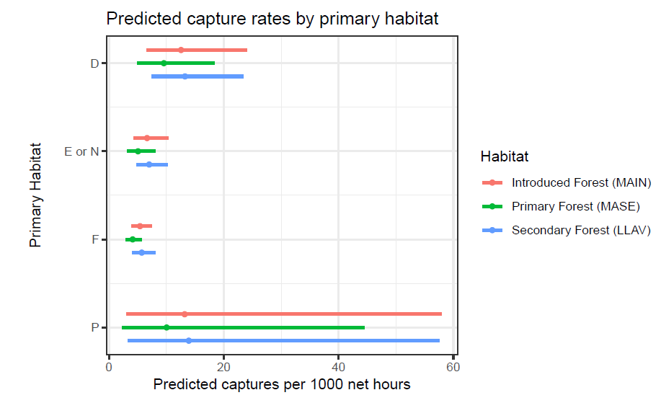

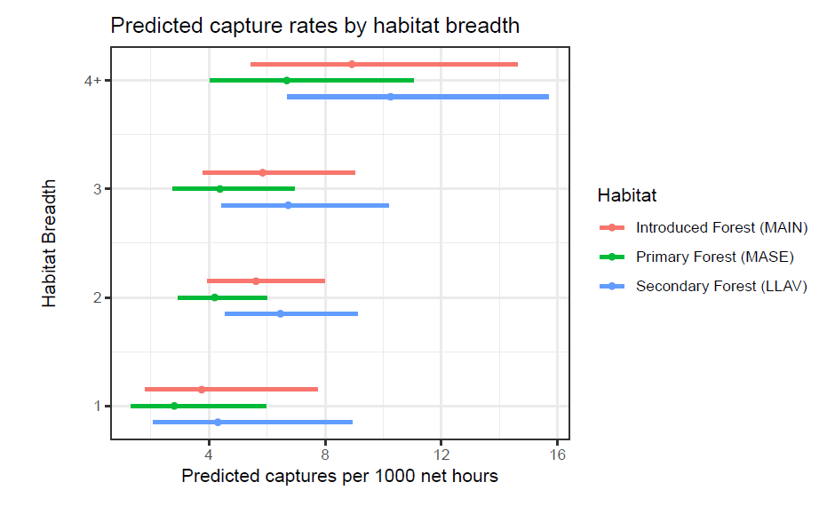

Appendix 1: General format of GLMM models in R using glmmTMB. Capture rate was modeled as a function of time and habitat type with random intercepts and random slopes for each species nested within each habitat. We compared different distributions, including Poisson, negative binomial, zero-inflated Poisson, zero-inflated negative binomial, and the negative binomial distribution with and without an autoregressive correlation structure. Based on AIC (Akaike 1974), the negative binomial model with autoregressive correlation structure performed best.

TODO:

(1|year)?;

put in methods about how sessions included in time, eg yr 1.3, 1.6, 1.9;

is time centered? Does it matter?

fit_nb2_corr <- glmmTMB(N ~ 1 + # 1

Location + # 2

time_cts + # 3

(1|Specie.Code:Location) + # 4

time_cts + 0|Specie.Code:Location)+ # 5

ar1(as.ordered(time_cts) + 0|Specie.Code) + # 6

offset(log(tot_net_hours)), #7

family = nbinom2, #8

data = ecuador)

# Key:

# 1:Intercept

# 2:Location list locations

# 3:Continuous time variable

# 4:Species-specific intercept

# 5:Individuals slopes for each species-location combination

# 6:Temporal autocorrelation

# 7:Offset for effort

# 8:negative-binomnial error distribution

Emily original: screen grab

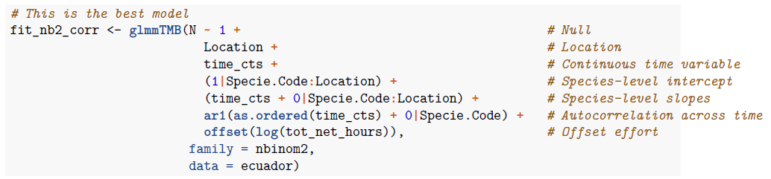

Appendix 2: Model selection to determine temporal autocorrelation structure. AR1-refers to a temporal autocorrelation with a 1-year time lag.

|  |  |  |  |  |
| --- | --- | --- | --- | --- |
|  | **dAIC** | **AIC** | **logLik** | **df** |
| Neg-binomial2 AR-1 | 0.00 | 6794.2 | -3388.1 | 9 |
| Poisson AR-1 | 12.69 | 6806.9 | -3395.4 | 8 |
| Negative-binomial2 | 18.69 | 6812.9 | -3399.4 | 7 |
| Zero-inflated binomial2 | 20.69 | 6814.9 | -3399.4 | 8 |
| Zero-inflated Poisson | 529.90 | 7324.1 | -3655.0 | 7 |
| Poisson | 608.68 | 7402.8 | -3695.4 | 6 |

**Appendix 3.** Sensitivity analysis to determine criteria for including species in GLMM models. The minimum amount of data to fit a regression model is three points. To determine if including time series with few data points biased our results we conducted a sensitivity analysis where we progressively included only time series with more observations. We first fit our GLMM model using all time series where a species had been observed in at three least different years for a given site. That is, data were only excluded if it was for a species that hand only been observed one (singletons) or twice at a given site during the study. We then iteratively removed each species that had only been observed three times at a site from the data and re-fit the model. After all species observed only three times were individually removed, we removed all of them and repeated the process by individually removing each species observed only four times from the model. This process was continued until only species observed seven or more years remained in the model (far-right of the plot).

The y-axis is the plot below is the estimated trend for a species, and the x-axis is an index which increases as more species are removed from the model. The thick black horizontal line is the main time effect of the model, which represents that average trend across all species. Each multicolored horizontal line each represent a species/habitat combination and its time trend, extracted from the species-specific random slopes of the model. The vertical black line represents results where time-series consisted of at least four observes, which was used for our reported results.

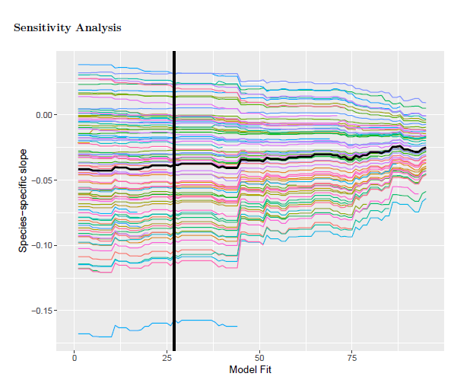

Appendix 3.

**Appendix 4:** Transformed species-level estimates (95% CI lower bound, estimate, 95% CI upper bound) for 38 species in three habitats in the High Andes of Ecuador.

